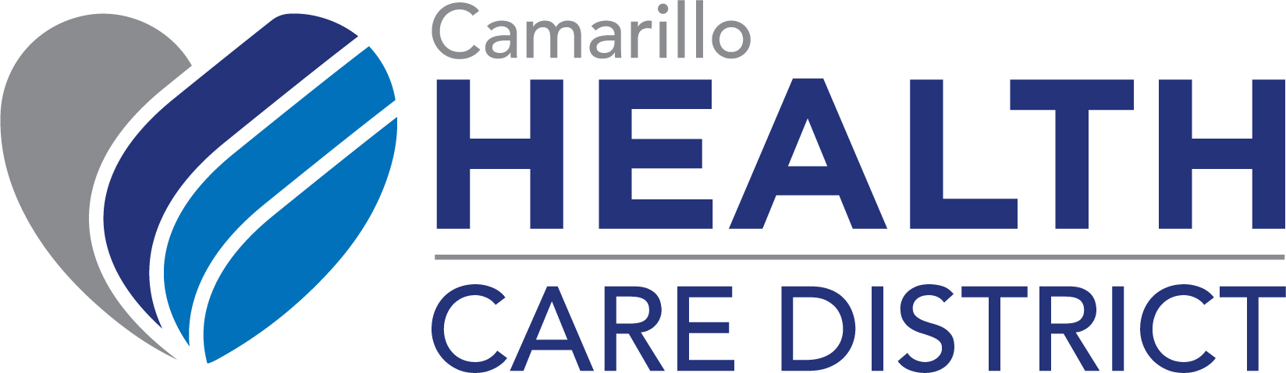
MINUTES October 26, 2021

Regular Meeting of the Board of Directors
Zoom Meeting – Meeting ID: 874 2811 0983

Board of Directors - Present | Staff - Present
Christopher Loh, MD, President | Kara Ralston, Chief Executive Officer
Tom Doria, MD, Vice President | Sonia Amezcua, Chief Administrative Officer
Mark Hiepler, ESQ, Director | Karen Valentine, Clerk to the Board
Martin T. Daly, Director
Participants: | Guests
Rick Wood, Financial Services Vendor, CSDA
Shalene Hayman, Hayman Consulting

1. Call to Order and Roll Call - The Regular Meeting of the Camarillo Health Care District Board of Directors was called to order on Tuesday, October 26, 2021, at 12:02 p.m., by
Christopher Loh, President.

2. Pledge of Allegiance – Director Doria

3. Amendments to The Agenda – None

4. Public Comment – None

5. Presentations – None

6. Consent Agenda - It was MOVED by Director Daly, SECONDED by Director Doria, and MOTION PASSED that the Board of Directors approve the Consent Agenda as presented.

Roll Call Vote: Ayes: Loh, Doria, Hiepler, Daly Nays: None Absent: Loft

7. Action Items

A. Review/ Discussion /Action – Consideration, discussion, and recommendation for approval of District Check Register, Check Register Comparison, Financial Reports, and monthly Investment and Designated Reserve Report for period ending September 30, 2021.

Director Hiepler left the meeting at 12:31 p.m.

It was MOVED by Director Loh, SECONDED by Director Daly, and MOTION PASSED that the Board of Directors approve the District Check Register, Check Register Comparison, Financial Reports, and monthly Investment and Designated Reserve Report for period ending
September 30, 2021.

Roll Call Vote: Ayes: Loh, Doria, Daly Nays: None Absent: Loft, Hiepler

B. Review/ Discussion /Action – Consideration, discussion, and recommendation for approval of District Resolution 21-11 Re-Authorizing Remote Teleconference Meetings of the Board of Directors for a 30-Day Period.

It was MOVED by Director Daly, SECONDED by Director Doria, and MOTION PASSED that the Board of Directors approve District Resolution 21-11 Re-Authorizing Remote Teleconference Meetings of the Board of Directors for a 30-Day Period.

Roll Call Vote: Ayes: Loh, Doria, Daly Nays: None Absent: Loft, Hiepler

C. Review/ Discussion /Action – Consideration, discussion, and recommendation for approval of District Resolution 21-12, Recognizing November 2021 as National Family Caregivers Month.

It was MOVED by Director Doria, SECONDED by Director Daly, and MOTION PASSED that the Board of Directors approve District Resolution 21-12, Recognizing November 2021 as National Family Caregivers Month.

Roll Call Vote: Ayes: Loh, Doria, Daly Nays: None Absent: Loft, Hiepler

8. Chief Executive Officer Report

CEO Ralston reported that Assemblymember Jacqui Irwin and State Senator Monique Limon made a special presentation to the District of COVID Community Response funding from the State of California, in amount of $330,000.00. Chair Loh and Director Daly attended, and the presentation was streamed live on Facebook.

Facility upgrades required by Environmental Health in order to relocate the Senior Nutrition Program from Freedom Park back to our Camarillo facility have received approval. The upgrades included new flooring with continuous coving, automatic doors, updated restroom and lockers for SNP staff. The move is scheduled for early November.

CEO Ralston will be participating in the Local Agency Formation Committee meeting on November 17, 2021, when they will be reviewing the District’s Sphere of Influence.

9. Board President’s Report

Nothing new to report.

10. Having no further business this meeting was adjourned at 1:06 p.m.

____________________
Christopher Loh
Board President

